**Introduction …**

Quality Tours are a company that develops software for the travel industry. The company has identified an opportunity in the market for travel agents to search for flights on behalf of their customers. They have a requirement for an application, built from simple technology, that allows users to search for flights between London and Paris. Quality Tours are keen to adopt a phased approach whereby the first release is a flight search feature for one route only. Over time, they expect to enhance the application such that more routes can added and tickets can actually be reserved and purchased. The additional functionality will be developed and made available in future releases.

Quality Tours have defined the following acceptance criteria ...

The application will be used by travel agents on behalf of their clients. The travel agent will be given a unique user name and password to log on to the application. If the user credentials are correct then the user should log on successfully and a welcome message should be displayed. If the user credentials are incorrect then an error message should be displayed.

The travel agent will search for flights based on the route selected - London to Paris. There are two airports in London (Gatwick, Heathrow) and two airports in Paris (Charles de Gaulle, Orly). The travel agent should also select the class of flight (Coach, Premium Economy, First) and the number of tickets required. On searching for flights, the application should display the flight details selected (route, class, tickets) and the flights available (airline) and cost (ticket cost, total cost).

The travel agent should be able to conduct multiple searches in order to offer the available prices. The flight details should be cleared and updated

after each search. Once complete, the travel agent should close the application.

Quality Tours have adopted the traditional approach to software development in that an developer codes the application and hands it over for testing. The developer is a junior developer but has ensured that the code is high quality and has supplied unit tests which give > 90% coverage. The developer has also supplied automated functional tests. The developer is confident that the application is good enough to release.

**The challenge ...**

Your job is to test the application to ensure that it is ready for release. Travel agents are expecting to use the application immediately so you need

to ensure that it is tested on their behalf. You are expected to identify bugs through ...

* Static inspection - review the code without launching the application.
* Unit Testing - review and enhance unit tests to verify functionality.
* Service Tests - review and enhance the automated tests using the fixtures supplied.
* UI Tests - review and enhance the automated test.
* Exploratory testing - conduct additional manual test cases to supplement the automated tests.

Are there any bugs? if so, how many and what are they ? (hint > 10). Then consider …

* How many / what percentage of defects were found.
* How easy were the bugs to detect.
* Were any critical to the business.
* How could they have been avoided.
* Can Agile development techniques help.

**Notes for Trainers …**

* Focus solely on the Acceptance Criteria. Is it sufficient (no) and could it be improved. Could it be written in BDD / TDD. Host a SBE workshop.
* Focus on Static Anaysls / Unit Testing. Is the code acceptable, can it be improved. Highlight the lack of declarations (final) Highlight the 90% code coverage yet doesn’t find all defects.
* Focus on FitNesse. Use the tests as templates but extend the tables to cover every combination.
* Focus on UI testing. What tools are available, how long to create a test, how long to execute a test suite. Review techniques (parametisation / Collelation / Data Driven Testing / Keyword Driven testing etc)
* Focus on Exploratory testing. Have individuals test in isolation and highlight if they focus on the same areas. Have folks work together and compare the number of issues found.
* Focus on non-functional testing. Is the architecture useable, scalable, performant, secure (view passwords in notepad!). Review error handling (to screen / error log). How could the UI be improved to make it more intuitive
* Etc, etc, etc

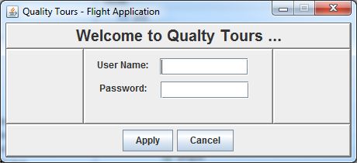

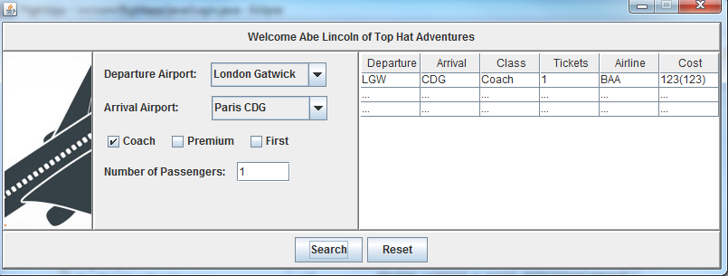

|  |  |  |  |
| --- | --- | --- | --- |
| Defect UI | Testing Stage | Priority (High / Medium / Low) | Description |
| 1 |  |  |  |
| 2 |  |  |  |
| 3 |  |  |  |
| 4 |  |  |  |
| 5 |  |  |  |
| 6 |  |  |  |
| 7 |  |  |  |
| 8 |  |  |  |
| 9 |  |  |  |
| 10 |  |  |  |
| 11 |  |  |  |
| 12 |  |  |  |

!define TEST_SYSTEM {slim}

!path ../projects/QualityTours/bin

|import |

|com.flightapp.java|

!1 Get Flight Details

!3 This test verifies that the 'GetFlightDetails' feature returns the specific flight for the departure & arrival airport combination.

|Get Flight Details Fixture |

|departure|arrival|tktclass?|airline?|airfare?|

|LGW |CDG |Coach |BAA |123 |

|CDG |LGW |Coach |BAA |213 |

!1 Get User Credentials

!3 This test verifies that the 'GetUserCredentials' feature returns the user details for the specified user.

|Get User Credentials Fixture |

|firstname|lastname?|company? |

|Admin |Admin |Admin Admin Admin |

|Abe |Lincoln |Top Hat Adventures|

|Bill |Clinton |Big Sax On Tour |

!1 Get Airports Returns All Airports

!3 This test verifies that the 'GetAirports' feature returns all airports from the data store.

|Query:Get Airports Fixture|

|airports |

|London Gatwick |

|London Heathrow |

|Paris CDG |

|Paris Orly |